REG/APP/F001

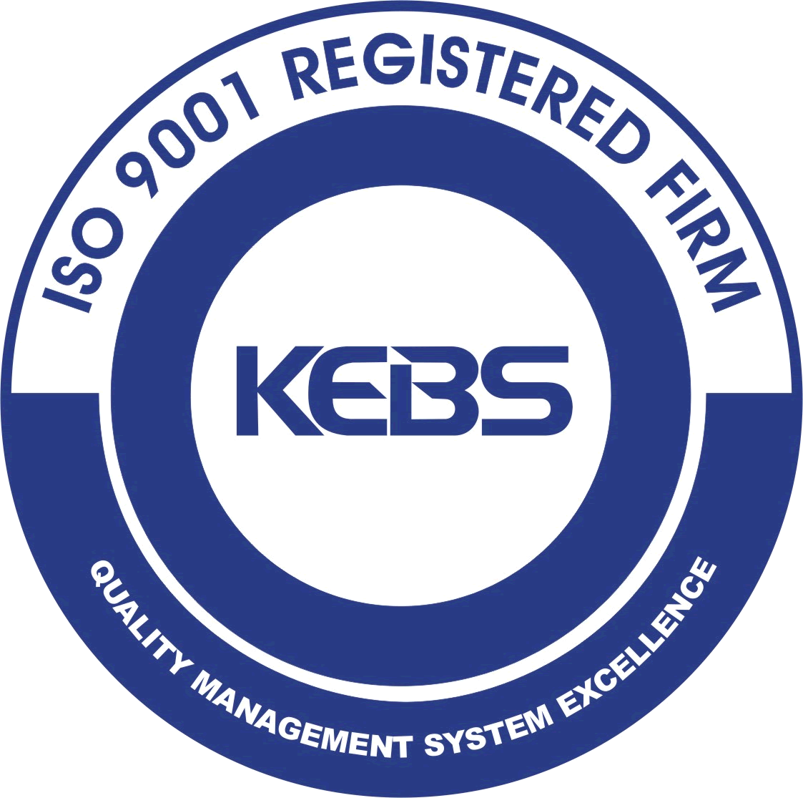
MACHAKOS UNIVERSITY
ISO 9001:2015 Certified

APPLICATION FORM FOR ADMISSION TO CERTIFICATE, DIPLOMA AND DEGREE PROGRAMMES

A copy of this form should be completed and returned/sent to the Registrar. The form should be typed or completed in block letters. Attach a passport size photograph, a copy of result slip/certificates and a copy of the national ID Card.
NB: Application fee for Certificate and Diploma courses is Ksh 500/=, for Degree Courses is Ksh.1,000/=, Ksh. 2,000/= and 3,000/= for Masters and PhD Programmes respectively, payable in any of the following bank accounts.

Kenya Commercial Bank: - Account No. 1137145064
National Bank of Kenya: - Account No. 01020078499400
Standard Chartered Bank - Account No. 0152016845602

SECTION A - Course Application Details

(i) Name of Certificate/Diploma/Degree /Masters/PhD Course applied for…………………………………………………
(ii) School……………………………………………………………………………………………………………………..
(ii) Department………………………………………………………………………………………………………………...

SECTION B – Applicant’s Personal Details

(i) Name………………………………………………………………………………………………………………………
(Surname) (Other names in full)

(ii) Postal Address………………………………………………………. Postal Code………………………………….

Town/City…………………………………………………………… Country……………………………………...

Phone……………………….. Fax……………………………….. E-mail……………………………………….

(iii) Date of Birth (DD/MM/YYYY)………………………………………. Male Female

Marital Status…………………………………………… Religion………………………………………………………

Nationality……………………………… National ID…………………….. Passport No………………………...

(iv) Name of Next of Kin…………………………………………………… Relationship…………………………………

Postal Address…………………………………………………………. Postal Code………………………………….

Town/City……………………………………………………………… Country……………………………………..

Phone……………………………….. Fax………………………… E-mail……………………………………….

SECTION C - Applicant’s Education Details

Please fill in the table by listing all the secondary schools and colleges attended

Secondary School and College attended | Address of School/College | Period of Study |  | Qualification | Index No
Secondary School and College attended | Address of School/College | From | To | Qualification | Index No

Please attach certified copies of certificates, academic transcripts, results slips and any relevant document.

SECTION D – Applicant’s Working Experience (if applicable)

Please fill in the table by listing all your working experiences

Period of Work |  | Employer | Designation | Nature of Assignment
From | To | Employer | Designation | Nature of Assignment

SECTION E - Applicant’s Declaration

I declare that the information given herein is true and accurate to the best of my knowledge and fully understand that any information found to be false would lead to automatic disqualification.

Name of Applicant in full………………………………………………………………………………………………………….

ID/Passport No………………………………….. Date………………….. Signature…………………………...

SECTION F – Evaluation of Applicant (for official use only)

(i) Application form received

Signed………………………………………………… Date and Stamp……………………………………………...
Registrar (Academic & Student Affairs)

(ii) Recommendation of Department Accept/Reject

Signed…………………………………………………. Date and Stamp……………………………………………..

Head of Department……………………………………………………………………………………………………..

(iii) Recommendation of School Accept/Reject

Signed………………………………………………… Date and Stamp……………………………………………..

Dean of School…………………………………………………………………………………………………………..

